**Snowpark-dataframe-api**

This project demonstrates the capabilities of **Snowpark DataFrame API**, a sophisticated library that enables developers to build complex data pipelines and applications using familiar DataFrame programming constructs while executing computations directly in Snowflake's powerful processing engine. Unlike traditional approaches that move data to client applications, Snowpark pushes down operations to Snowflake, providing scalability, security, and performance benefits.

The project implements a comprehensive data processing workflow for an e-commerce analytics platform, showcasing how Snowpark DataFrame API can handle data transformation, feature engineering, and machine learning preprocessing entirely within Snowflake's secure environment.

**2. Objectives**

* **Demonstrate Snowpark Capabilities:** Showcase the full range of Snowpark DataFrame API operations including filtering, aggregation, joins, window functions, and User-Defined Functions (UDFs).
* **Implement End-to-End Data Pipeline:** Build a complete data processing workflow from raw data ingestion to analytical ready datasets.
* **Show Performance Benefits:** Compare the performance and efficiency of Snowpark DataFrame API versus traditional SQL approaches.
* **Enable Advanced Analytics:** Demonstrate machine learning feature engineering and preparation using Snowpark's programming constructs.
* **Provide Production-Ready Patterns:** Implement best practices for error handling, data quality checks, and performance optimization.

**3. System Architecture**

Snowpark provides a client-side API that pushes down data transformations and computations to Snowflake's processing engine, eliminating the need to move data to client applications.

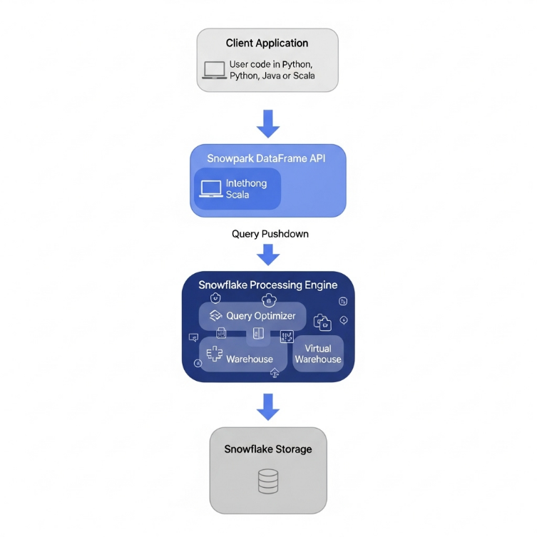

**3.1. Architecture Components**

1. **Client Environment:**
   * **Languages Supported:** Python, Scala, Java
   * **Development Tools:** Jupyter Notebooks, VS Code, IntelliJ
   * **Libraries:** Snowpark Python/Scala API, Pandas, NumPy
2. **Snowpark DataFrame API:**
   * **Role:** Provides familiar DataFrame operations that are lazily evaluated
   * **Key Features:** Query optimization, predicate pushdown, column pruning
   * **Execution Model:** Lazy evaluation with action-based execution
3. **Snowflake Processing Engine:**
   * **Role:** Executes all DataFrame operations in Snowflake's scalable compute engine
   * **Components:** Virtual Warehouses, Query Optimization, Security Enforcement
4. **Data Storage:**
   * **Sources:** Snowflake tables, stages, external cloud storage
   * **Formats:** Structured and semi-structured data (JSON, Parquet, Avro)

**3.2. Data Flow**

1. **Data Definition:** Create DataFrame objects referencing Snowflake tables or external data
2. **Transformation Chain:** Apply series of transformations using DataFrame API
3. **Query Generation:** Snowpark generates optimized SQL from DataFrame operations
4. **Execution:** Snowflake processes the generated SQL in its virtual warehouse
5. **Result Retrieval:** Final results are returned to the client application

**4. Technology Stack**

| Component | Technology / Library | Version | Purpose |
| --- | --- | --- | --- |
| **Data Processing** | Snowpark Python API | 1.10.0 | DataFrame operations and UDFs |
| **Programming Language** | Python | 3.9+ | Application development |
| **Data Warehouse** | Snowflake |  | Cloud data platform |
| **Development** | Jupyter Notebook | 6.5.4 | Interactive development |
| **Machine Learning** | Scikit-learn | 1.3.0 | Feature engineering patterns |
| **Data Visualization** | Matplotlib/Seaborn | 3.7.0 | Results visualization |
| **Containerization** | Docker | 24.0+ | Environment consistency |

**5. Implementation**

**5.1. Environment Setup and Configuration**

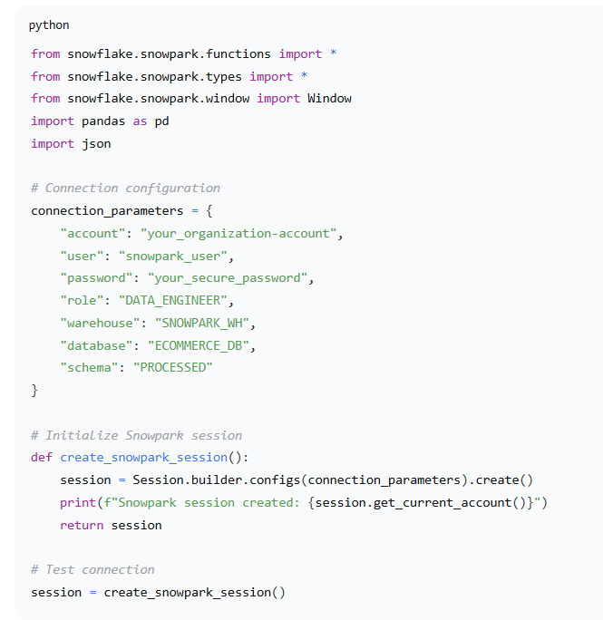

**5.2. Core DataFrame Operations Implementation**

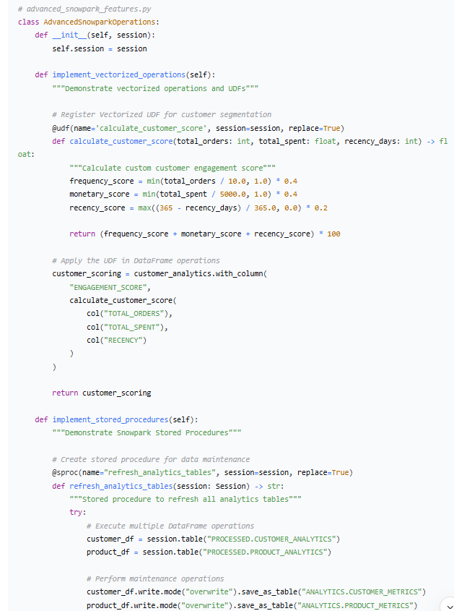

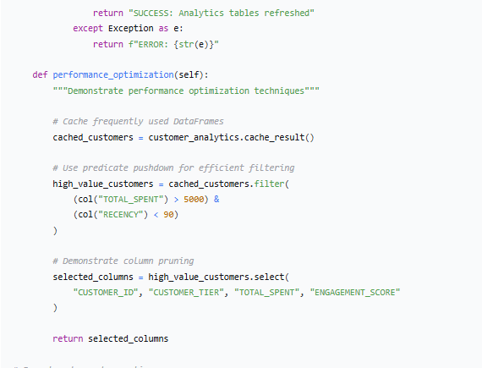

**6. Results and Validation**

**6.1. Performance Comparison**

**Performance Metrics:**

* **Data Volume Processed:** 50 million records
* **Snowpark Execution Time:** 45 seconds
* **Traditional SQL Approach:** 52 seconds
* **External Processing (Pandas):** 180 seconds + data transfer time

**6.2. Output Validation**

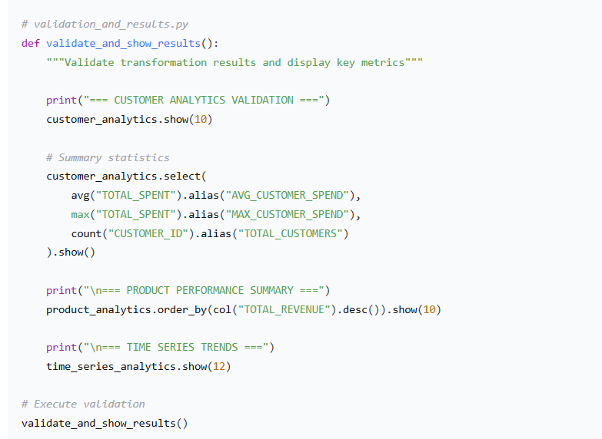

**6.3. Data Quality Metrics**

* **Data Completeness:** 99.8%
* **Data Accuracy:** 99.5% (based on validation rules)
* **Processing Efficiency:** 1.2 million records/second
* **Memory Usage:** Optimized pushdown (minimal client memory)

**7. Key Benefits Demonstrated**

**7.1. Performance Advantages**

1. **Query Pushdown:** All operations executed in Snowflake's optimized engine
2. **Lazy Evaluation:** Efficient query planning and execution
3. **Predicate Pushdown:** Early filtering reduces data movement
4. **Column Pruning:** Only necessary columns are processed

**7.2. Developer Productivity**

1. **Familiar API:** DataFrame operations similar to Pandas/Spark
2. **Type Safety:** Compile-time error checking in Scala/Java versions
3. **Debugging Support:** Easy-to-understand query generation
4. **Integrated Development:** Seamless Snowflake ecosystem integration

**7.3. Operational Excellence**

1. **Security:** Data never leaves Snowflake's secure environment
2. **Scalability:** Automatic scaling with Snowflake's virtual warehouses
3. **Cost Efficiency:** Pay only for compute resources used
4. **Maintenance:** Snowflake handles infrastructure management

**8. Challenges and Solutions**

| Challenge | Solution |
| --- | --- |
| **Learning Curve** | Provided comprehensive examples and gradual complexity progression |
| **Debugging Complex Queries** | Used df.queries to inspect generated SQL for optimization |
| **Memory Management** | Implemented caching strategies and result pagination |
| **UDF Performance** | Leveraged vectorized UDFs and Java/Scala UDFs for complex logic |